**School:** Computer Science

**Institution:** University of Windsor

**Term:** Fall 2019

**Course:** Comp-3150 (03-60-315-1) : Database Management Systems

**Instructor:** Dr. C. I. Ezeife

**Assignment #**2: Total: 50 marks

**Handed Out:Thurs. Sep. 26, 2019; Due Thurs Oct. 24, 2019**

**Objective of Assignment**: To test on knowledge and design of relational model constraints, relational database schemas, functional dependencies and normalization of relational databases.

**Scope**: Assignment covers materials from Chapters 5 and 14 of book discussed in class.

**Electronic Assignment Submission:** Done through <http://blackboard.uwindsor.ca>

**Marking Sheme** : The mark for each of the questions is indicated beside each question.

**Academic Integrity Statement**: Remember to submit only work that is yours and include the following confidentiality agreement and statement at the beginning of your assignment.

**CONFIDENTIALITY AGREEMENT & STATEMENT OF HONESTY**

**I confirm that I will keep the content of this assignment/examination confidential.**

**I confirm that I have not received any unauthorized assistance in preparing for or doing this assignment/examination. I confirm knowing that a mark of 0 may be assigned for copied work.**

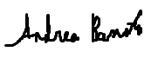 ____________________ _Andrea Bonato________

Student Signature Student Name (please print)

__104760390_______________________ __2019-09-21_________________

Student I.D. Number Date

**Marking Scheme : The mark for each question and sub question is shown with the question below. Place your solutions in tables where possible.**

**For office Use only**

|  |  |
| --- | --- |
| **Question** | **Mark** |
| **1** | **/20** |
| **2** | **/10** |
| **3** | **/10** |
| **4** | **/10** |
| **Total** | **/50** |

**CHAPTER 5: THE RELATIONAL DATA MODEL AND RELATIONAL DATABASE CONSTRAINTS**

1. (total marks 20) Given the same simple Employee-Workson-Project database schema you worked on in assignment 1, which contains three files described as follows:  
     
   Emp (eid : integer, ename : string, age : integer, salary: real)

Workson (eid : integer, pid : integer, hours : integer)

Project (pid : integer, pname : string, budget : real, managerid : integer)  
  
Note : eid, ename, age and salary are the employee id, name, age and salary respectively. Also, hours is the number of hours worked by employee on a project. The rest of the attributes pid, pname, budget and managerid are the project id, name, budget and managerid respectively. A manager is an employee.

Assume that an update is to be made to this database to enter information about a new project manager who is now the new manager of an existing project (replacing the old manager) and although he is new, he has worked some hours in another existing project. Answer the following questions on what specific relations, attributes and operations (eg. insert, modify, delete) that need to be done for this update to be implemented in the entire database.

Provide your answers both in descriptive sentences and using the formal database operations of INSERT, MODIFY, DELETE as used in Chapter 5 of book with specific attributes and relations when possible. An example formal insert of an employee record into the Emp table is:   
INSERT < eid, ename, age, salary> into Emp; // for new Employee record

And an example descriptive sentence is:   
i). do an insert operation for a new employee record into the Emp table.

(a) Give the set of needed insert, modify or delete operations for this update. 5 marks

(b) What types of integrity constraints (explain using attributes, eg, eid of relevant files)) would you expect to check for this update to be done? 5 marks

(c) Which of these integrity constraints are key, entity integrity, and referential (foreign key) integrity constraints and which are not? 5 marks

(d) Specify all the referential integrity (foreign key) constraints on this database in the format Referring_Relation.Attribute --> Referred_Relation.Attribute. 5 marks

(Total for que 1 is 20 marks)

Solution:

|  |  |
| --- | --- |
| **Question** | **Answers** |
| a. Give the operations for this update.  5 marks | //Since the manager is already an existing employee, and has worked hours on other projects, we do not need to insert into Emp  //Ensure that the temporarily deleted PID will not affect an other parts of the table. It can be associated with a brand new pid number for the new manager.  //Just in case we do need to insert the new employee, even if they should exist go to i) if not, skip the step II)   1. Do an INSERT operation for a new employee into the EMP table   INSERT<eid, ename, age, salary> into EMP   1. Do an MODIFY operation for the existing manager with a specific managerid into Project   MODIFY the eid in Project for the new managers project   1. Do an INSERT operation for a new relationship into the Workson table. Add the managers eid to work on the specific pid   INSERT<eid,pid,hours> into Workson  //If the old manager is going to be fired, then there would also need a delete operation on that manager’s eid in association to Emp |
| b. What types of constraints would you expect to check?  5 marks | We would need to check the various different constraints that both the INSERT and DELETE operations can affect. We would need to check to see if the value of the pid in the new tuple already exists in another tuple. We would also need to check to see if pid or eid is null in the new tuple. Similarly, we would need to check to see if the values of the primary key pid is being referenced from other tuples in the database. |
| c. Which of these constraints are key, entity integrity, and referential integrity constraints and which are not?  5 marks | The values that have to be weary of entity integrity are the primary keys pid and eid. In this case, when managing and deleting the tuples from Project, we have to be weary that the value of the pid can not be null. This is because when we insert it, when being referenced to it, it will cause errors and constraints in the database. The referential constraint is how the pid is referenced in both the Workson and the Project table. Without the pid existing, the referenced value will remain null and cause more constraints. |
| d. Specify all the referential integrity constraints on this database.  5 marks | A referential integrity relation is when a foreign key value in the new tuple references a primary key value that does not exist in the reference relation. This means that once one of the tuples are deleted, we must make sure that the primary key is not referenced in any other relationships. In this case, we must make sure that when we are temporarily deleting the specific project from the Project table, we must make sure that it’s PID is not being referenced in any other instances. This can be changed by using the RESTRICT option, CASCADE option and SET NULL options. Another referential integrity constraints are the when inserting, we must make sure that the PID that we are inserting exists |

1. (total marks 10) Using your own Employee-Workson-Project database instance from assignment 1, login to the SQL query processor on our cs server, called Oracle Sqlplus to create the three database tables and insert the tuples in your database state with the following sequence of instructions. Note that this exercise is to get you beginning to connect to SQLplus while preparing to learn full SQL language syntax in Chapters 6 and 7. You will be given the instructions to use now. Show the result of this exercise through a Unix script file you will attach.

(Total for que 2 is 10 marks)  
  
i. First connect to our cs.uwindsor.ca through either Bitvise SSH client or NoMachine

ii. Then create a script file to capture your Unix session and connect to Sqlplus with:

>script username_assn2que2  
>sqlplus <username>  
>password   
  
SQL>

CREATE TABLE Emp

(

eid number(10) NOT NULL,

ename varchar2(20),

age number(10),

salary number(20,2),

primary key (eid)

);

SQL> create table Project

(

pid number(10) not null,

pname varchar2(20),

budget number(10,2),

managerid number(10),

primary key(pid),

foreign key (managerid) references Emp(eid)

);

SQL> create table Workson

(

eid number(10) not null,

pid number(10) not null,

hours number(10),

primary key (eid,pid),

foreign key (eid) references Emp(eid),

foreign key (pid) references Project(pid)

);

SQL> insert into Emp values(10,'Jobe Bata', 25, 50000.00);

SQL> COMMIT;

// Repeat similar INSERT instructions for all the data in all your tables

// starting with the entity tables first, eg, Emp, Project, before WORKSON.

SQL> select * from cat; // to show all the objects in your catalogue

SQL> select * from Emp; // to show the contents of this table

SQL> exit //to exit sqlplus

>exit // to exit and create Unix script file to hand in

Solution: (10 marks)

|  |
| --- |
| An attached Unix script file showing execution of CREATE TABLE instructions and INSERT INTO tablnamee VALUES instructions with the few SELECT instructions to show contents of the catalogue and tables (your database instance). |

**CHAPTER 14: Database Design Theory: Introduction to Normalization Using Functional and Multivalued Dependencies**

**3.** (total marks 10) Consider the following relation:

Takes(Studid, Crsid, CTitle, Score, Lettergrade)

Assume that a student (Studid) may be enrolled in multiple courses (Crsid) and hence   
{Studid, Crsid} is the primary key.   
Thus, the following functional dependency exists:

{Studid, Crsid } -> {CTitle, Score, Lettergrade}

Additional dependencies are:

Crsid -> CTitle

Score -> Lettergrade

Based on the given primary key,

1. is this relation in 1NF, 2NF, or 3NF? Why or why not?
2. If not in 2NF at least, normalize it completely into 2NF and 3NF? Provide your answers using functional dependencies (FDs). (Total for que 3 is 10 marks)

Solution (i): (5 marks)

|  |
| --- |
| ***Answer:***  Since there is no composite attributes, multivalued attributes and the domain includes only atomic values, it is in 1NF. Since the primary key is a composite key, it is not 2NF. Since it is not 2NF, then it is not 3NF.  . |

Solution (ii) (5 marks)

|  |
| --- |
| **Answer:**  2NF:  EnrolledA(Studid, Crsid, Score, LetterGrade)  EnrolledB(Crsid, CTittle)  3NF:  EnrolledA(Studid, Crsid, Score)  EnrolledAA(Score, LetterGrade)  Enrolled2(Crsid, CTittle) |

**4.** (total marks 10) What (i) update, (ii) delete and (iii) insertion anomalies occur in the DEPARTMENT_PROJECT relation obtained by doing a natural join of the two relations DEPARTMENT and PROJECT of Fig 14.2 on page 463 of book? Explain with examples using this database and the DEPARTMENT_PROJECT relation schema with state given below as Figures 4.1 and 4.2 below. (Total for que 4 is 10 marks)  
Note: 3 marks for correct discussion of each anomaly and 1 mark for attempt.

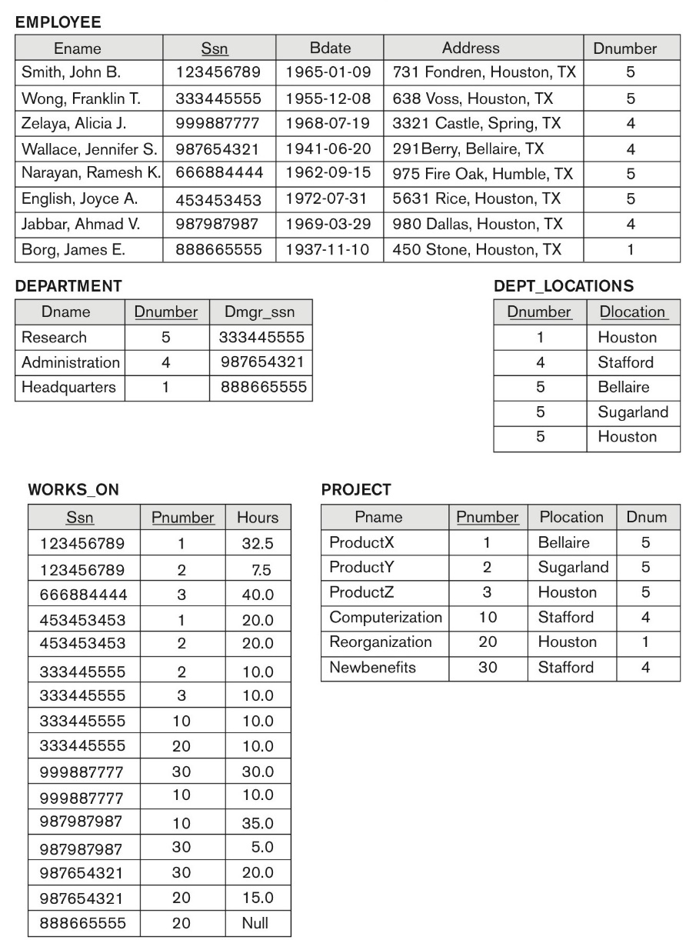

**Figure 14.2 (book):** Sample database state for a simplified COMPANY relation DB

****

Fig 4.1: DEPARTMENT_PROJECT DB schema suffering from update anomalies

FD1

FD2

FD3

Dnumber Pnumber Dname Dmgr_ssn Pname Plocation

***

Fig 4.2: A database state of the DEPARTMENT_PROJECT DATABASE derived from Fig 14.2

DNUMBER PNUMBER DNAME DMGR_SSN PNAME PLOCATION

---------- ---------- --------------- --------- --------------- ---------------

5 3 Research 333445555 ProductZ Houston

5 10 Research 333445555 Computerize Stafford

5 20 Research 333445555 Reorganize Houston

5 30 Research 333445555 Nbenefits Stafford

5 1 Research 333445555 ProductX Bellair

5 2 Research 333445555 ProductY Sugarland

4 3 Administration 987654321 ProductZ Houston

4 10 Administration 987654321 Computerize Stafford

4 20 Administration 987654321 Reorganize Houston

4 30 Administration 987654321 Nbenefits Stafford

4 1 Administration 987654321 ProductX Bellair

4 2 Administration 987654321 ProductY Sugarland

1 3 Headquarters 888665555 ProductZ Houston

1 10 Headquarters 888665555 Computerize Stafford

1 20 Headquarters 888665555 Reorganize Houston

1 30 Headquarters 888665555 Nbenefits Stafford

1 1 Headquarters 888665555 ProductX Bellair

1 2 Headquarters 888665555 ProductY Sugarland

18 rows selected.

Solution: (3 + 3 + 3 + 1 marks)

|  |
| --- |
| 1. Update: If someone changes Plocation, it must change for every single person and project that will be a that location. If someone changed plocation based on dname for one of the tuples, the other will change as well. 2. Delete: If people delete the values that are associated with the pname and dname, every other value with those corresponding with those attributes. For example, if you delete by the Pname ProductZ, all off them will be removed 3. Insertion: To insert into this relationship, the new tuple must contain both a dnumber and a pnumber. That means, that in order for a tuple to be eligible to be added, it must have an existing and corresponding department AND project or else it can not be immediately inserted |